Leo Turbet-Delof12:04 AM
We dont have pictures anymore here ? https://staging.lacuisinedebernard.com/recettes-salees/
We would need recipe cards with image and title
But here seems ok https://staging.lacuisinedebernard.com/recettes-sucrees/
Need to be centered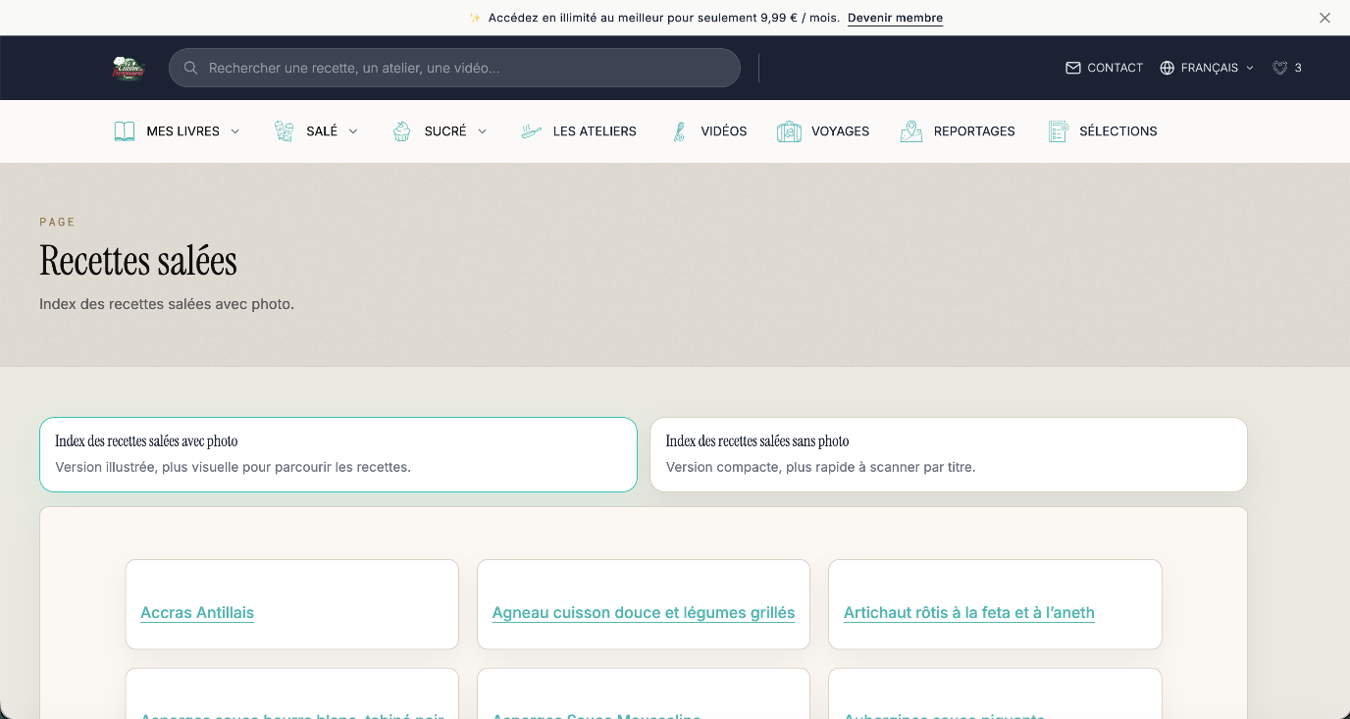
All need to have same padding in the right/left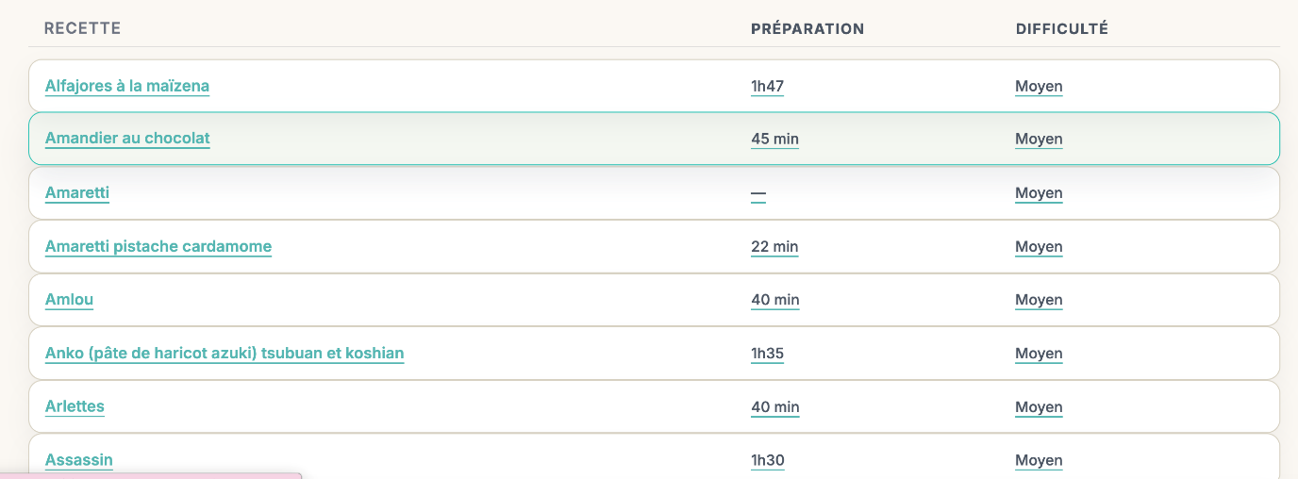

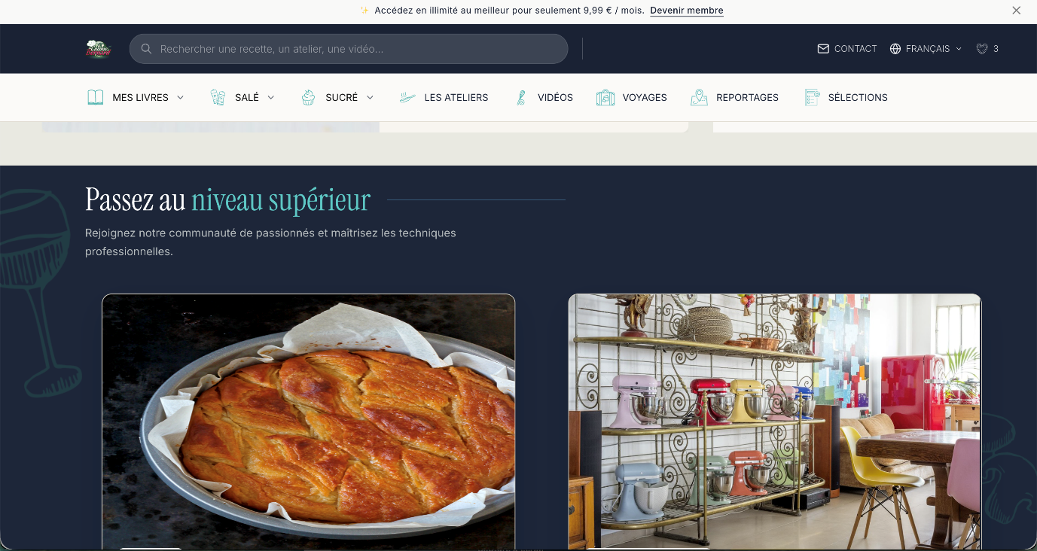
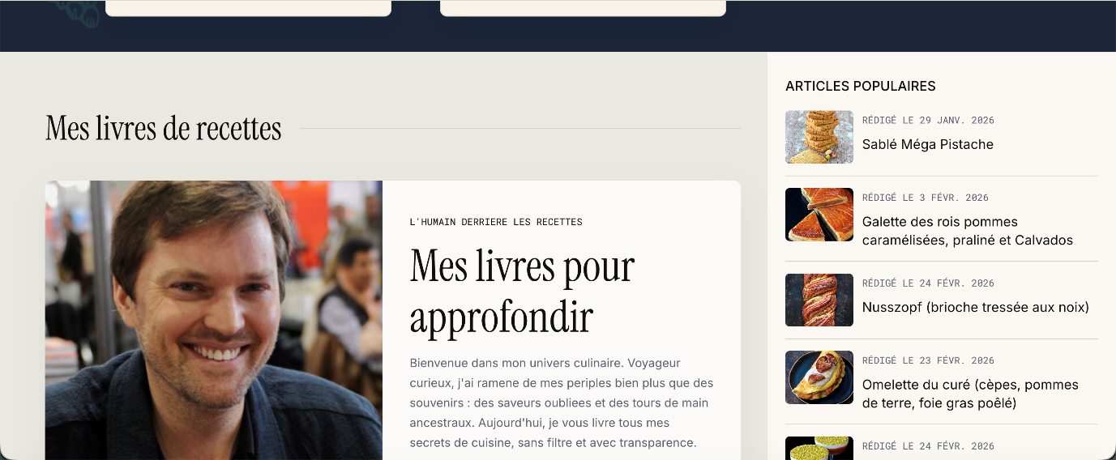
We need to have same spaces convention everywhere
Leo Turbet-Delof12:17 AM
Can you update the definitive wording ?
Leo Turbet-Delof12:38 AM
The text from recipes are a bit too big and we would need to have #313131
We can keep size we have on mobile on the card
Space issues
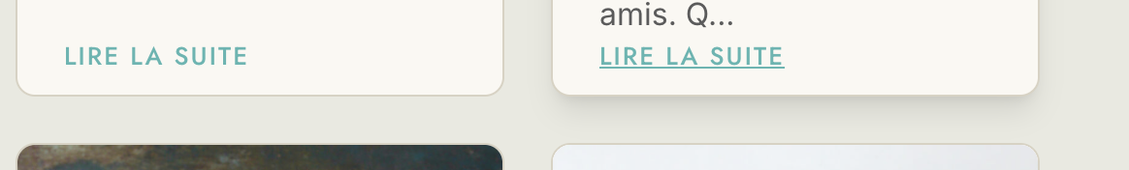
All font are too big (Heading, etc)
Not enough padding top/bottom on heading, etc
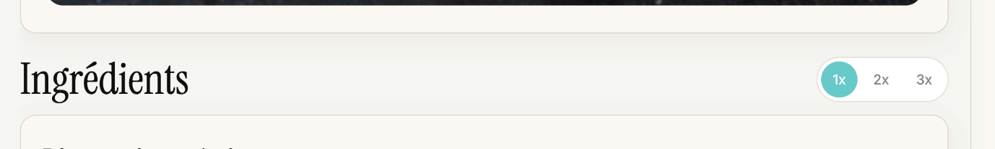
Add more padding top and bottom